Project:Hangman Game

# Tech Stack used:

* Python
* Tkinter (for GUI)

# Description :

Hangman is a paper and pencil guessing game for two or more players. One player thinks of a word and the other tries to guess it by suggesting the letters. The word to guess is represented by a row of dashes, giving the number of letters. If the guessing player suggests a letter which occurs in the word, the program writes it in all its correct positions. If the suggested letter does not occur in the word, the other player draws one element of the hangman diagram as a tally mark. The game is over when the guessing player completes the word, or guesses the whole word correctly. The gaming code will mainly contain the **class Hangman** which will provide the list of good letters as well as the no. of chances given to a user. We used python and one of its module **Tkinter** toolkits for GUI. **Tkinter** is the de facto way in **Python** to create Graphical User interfaces (GUIs) and is included in all standard **Python** Distributions.

1) *Formulate a word list (with or without a hint) and store them in a data structure with the list of all 26 alphabets of English language.*

*2) The actual method which does the logical reasoning, whether the letter exists or not, if yes, write it down at all the places else strike off a lifeline. This forms the main part of the code.*

*3) Final word to be displayed if guessed wrongly else, interactive message saying that “OK YOU GUESSED IT”*

*4) Finally, the GUI coding, user interactive screen which mainly prevails during the code output.*

We are using the **glib and gtk** libraries which are already available. Also planning and utilizing the **built in classes** and **submodules** of the tkinter toolkit as and when required.

# TEAM : CODE BREWER

|  |  |  |
| --- | --- | --- |
| NAME | **BRANCH** | YEAR |
| Shivangi Singh (leader) | Electronics and communication engineering | 2nd |
| Priya Singh | Electrical engineering | 2nd |
| Akanksha | Electrical engineering | 2nd |

# GitHub Repository Link:

<https://github.com/codebiet/Hangman>

# Presentation Video:

<https://drive.google.com/file/d/17bXfBFfeAFlRrG7yosxZ4x0DpeYexlLx/view?usp=sharing>

# ScreenShot:

*Starting of game*

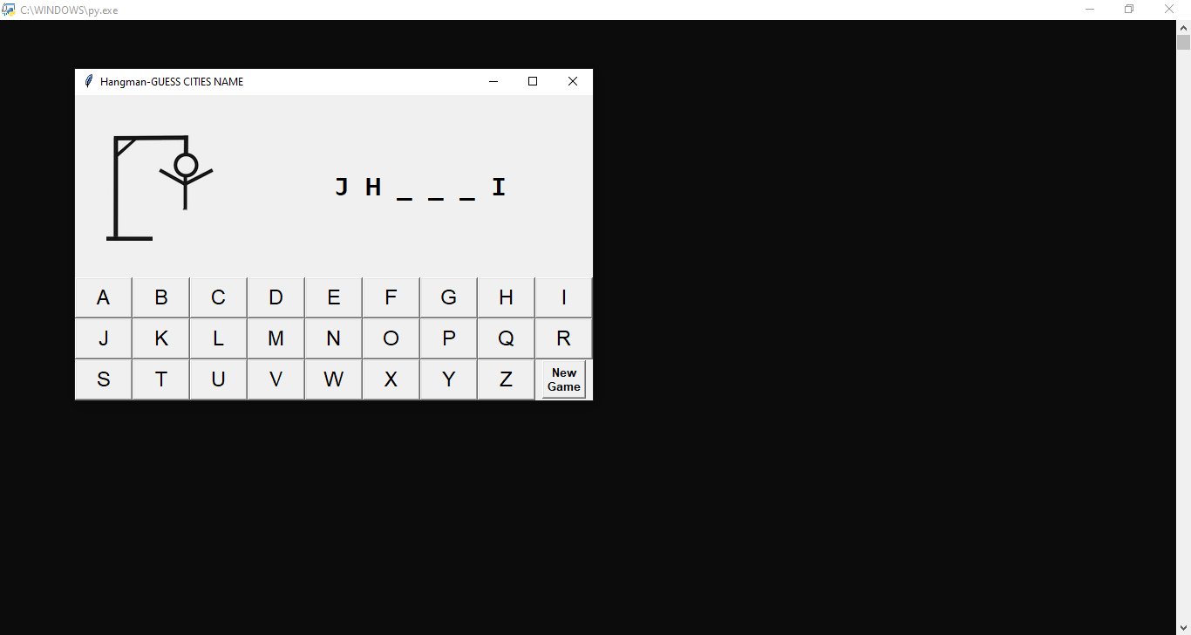*After 9 wrong guess*

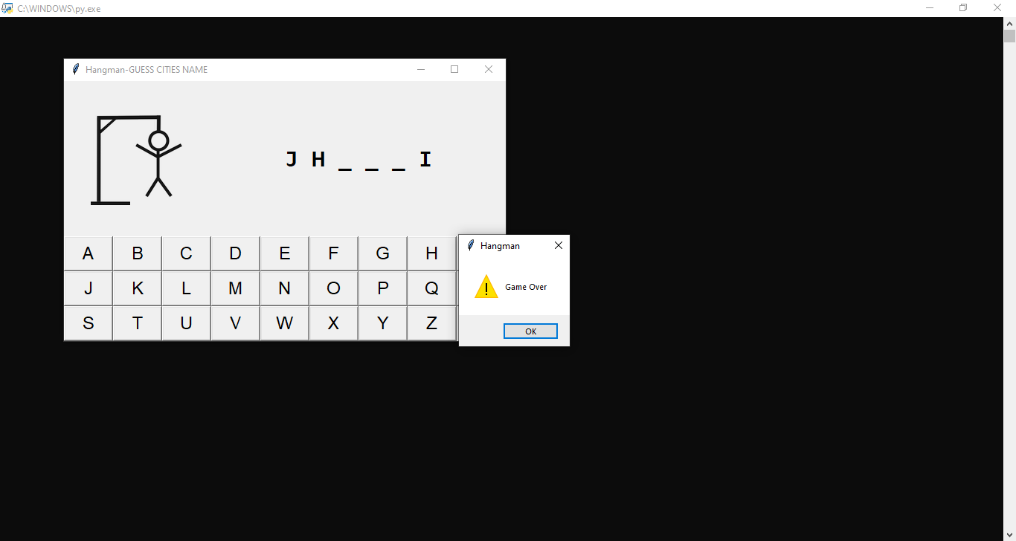*On all wrong guess (game over)*

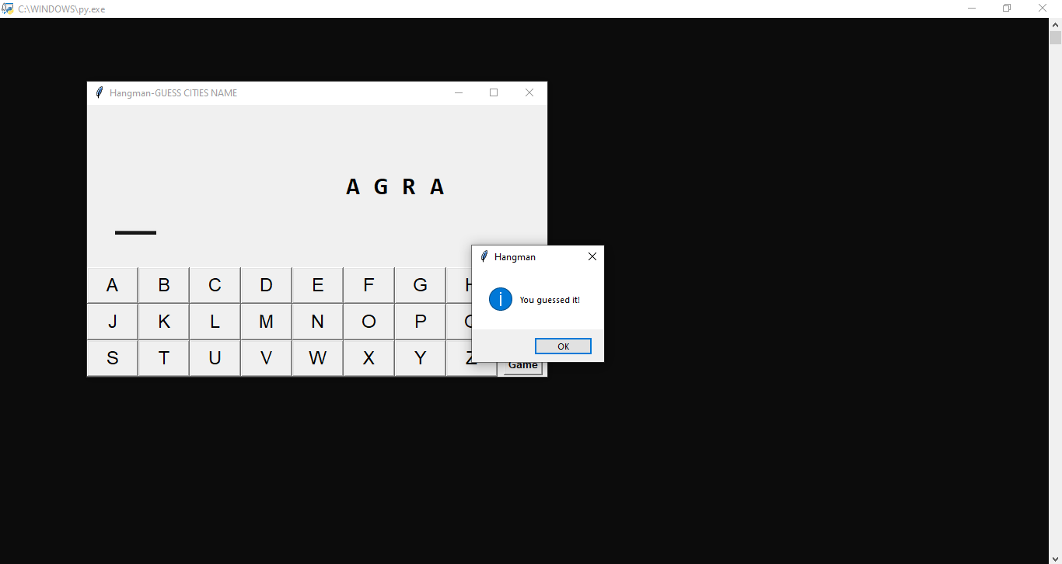*On all right guess (you won )*